Kenya Family Safari

**2010**

Ron Dawson

Quest Specialty Travel

6/18/2010

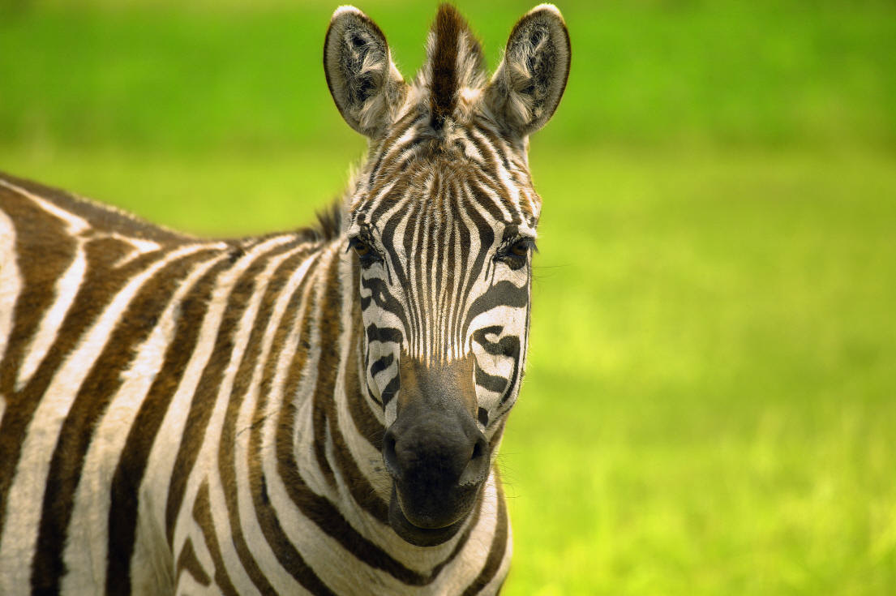

Kenya Family Safari

# Tour Itinerary

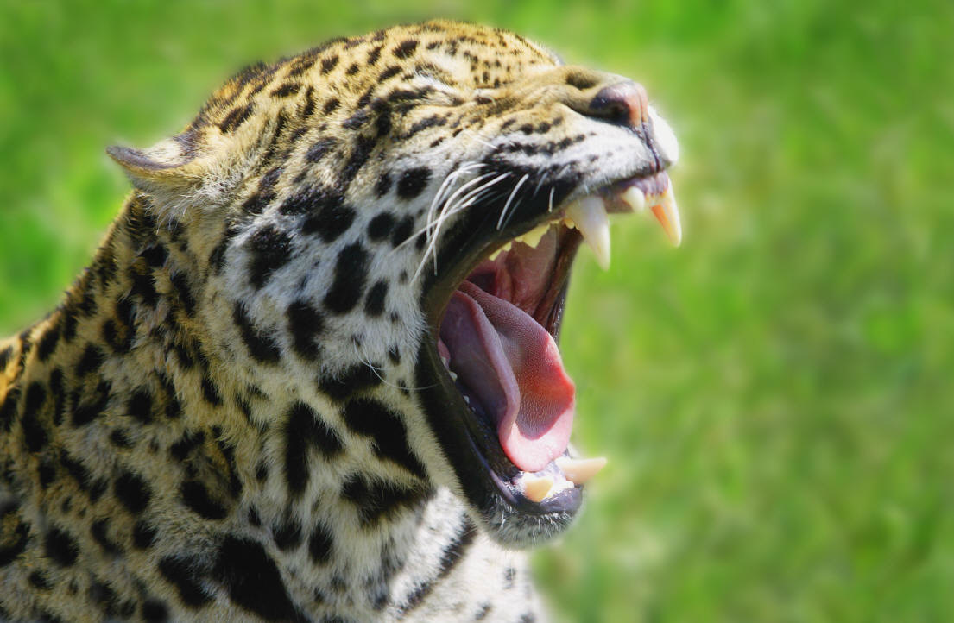

**Day 1**: Arrive in Nairobi and transfer to hotel.

**Day 2:** Tour Nairobi. Visit elephant orphanage, the Giraffe Center, and an African craft market.

**Day 3:**  Travel to Lake Nakuru National Park and take our first game drive, looking for flamingoes and other bird life.

**Day 4:** Morning game drive before travelling to nearby Lake Naivasha for an afternoon boat ride on the lake, in search of hippos.

**Day 5:**  Drive to bush camp in the grasslands of the Maasai Mara National Reserve. In the afternoon, game drive in search of the Big 5.

**Days 6 and 7:** Game drive in the Maasai Mara looking for lion, cheetah, leopard, zebra and wildebeest.Visit a Maasai village to learn Maasai crafts and dancing.

**Days 8 and 9:** Relax on the beach south of Mombasa.

**Day 10:** Train to Nairobi, where the tour ends.

10 days/9 nights, Begin/End Nairobi

# Tour Highlights

* Nairobi Craft Markets, Elephant Orphanage, and Giraffe Center
* Lake Nakuru National Park
* Lake Naivasha
* Maasai Mara Reserve
* Maasai Village
* Coral reefs and beaches

# Tour Summary

A family trip to Kenya is adventure travel, a wildlife safari, cultural holiday, and beach vacation all rolled into one. In colorful Nairobi, we check out the fantastic African crafts at the local market, feed the giraffes at the Giraffe Center and spend time with orphaned elephants at the elephant orphanage. The next day we head for the bush, stopping first at the Rift Valley lakes, where we hope to see thousands of pink flamingos create a colorful carpet across the surface of the water. Our game drive at Lake Nakuru promises bird life, and then we explore Lake Naivasha by boat, looking for hippos. Next, we spend two days in the spectacular grasslands of the Maasai Mara Reserve, watching for herds of wildebeest, zebra, and gazelle, closely followed by their predators–lion, hyena, cheetah, and the elusive leopard. Our trip ends at the Indian Ocean, where we enjoy white sand beaches and the best coral reefs in Africa.

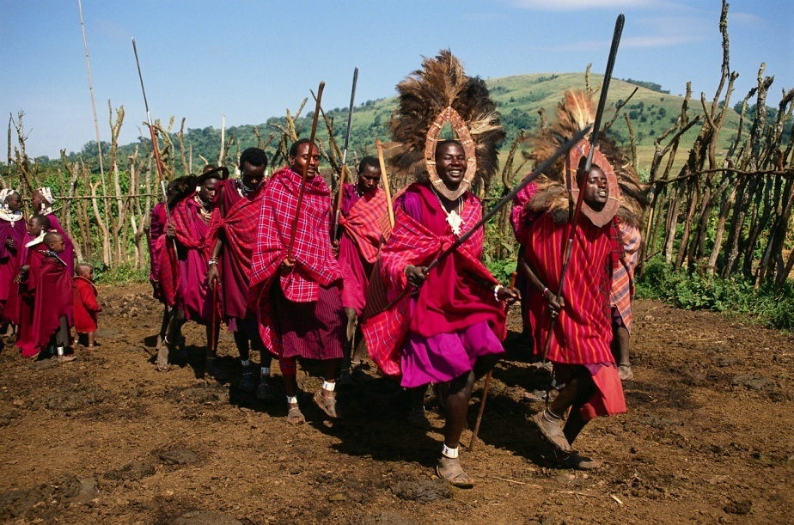

# Practical Information

### Travelling with Children

Kenya is a wonderful place for families to visit, but the usual health precautions apply. No vaccinations are required for travel to Kenya, but we recommend protection against malaria, typhoid, tetanus, diphtheria, polio, and hepatitis A. Malaria is a risk in all areas except Nairobi and the highlands.

Travelers' diarrhea is the most common ailment affecting tourists in Kenya, and children are particularly susceptible. Take care to drink bottled water and avoid fruits or vegetables that have not been peeled. Consult your travel clinic or healthcare provider for advice.